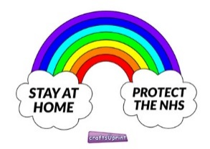
Stay Safe…Stay at Home
Craft ideas for Easter using things you may at home.
Recycled card, coloured cut outs from birthday cards, magazines and cardboard boxes.
Cotton wool from makeup pads, cotton wool balls The shapes are simple to draw and cut out. Then you will need glue or tape. Decorate with any creative ideas you have from finger paint!! To buttons, gems, sticky shapes.

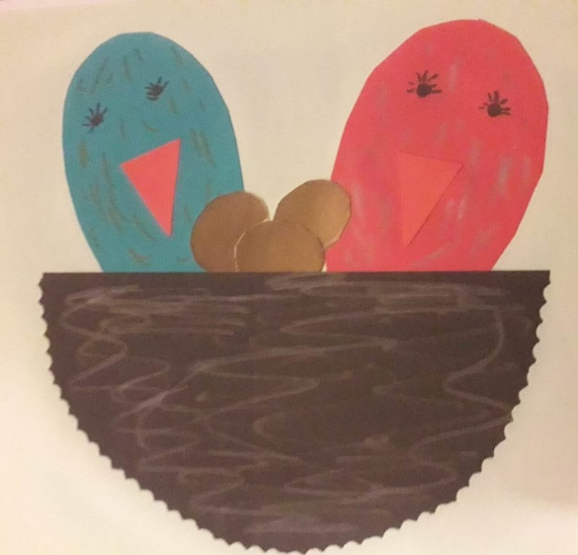
An Easter Nest with chicks
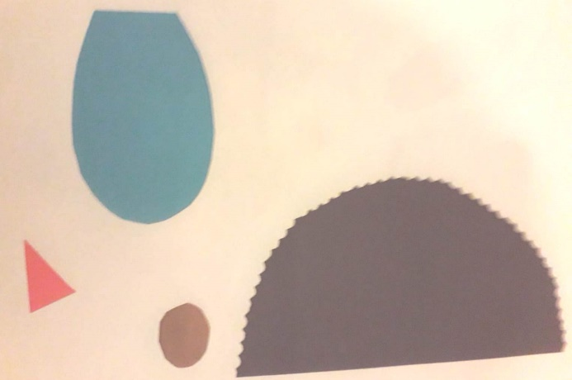
The shapes you need
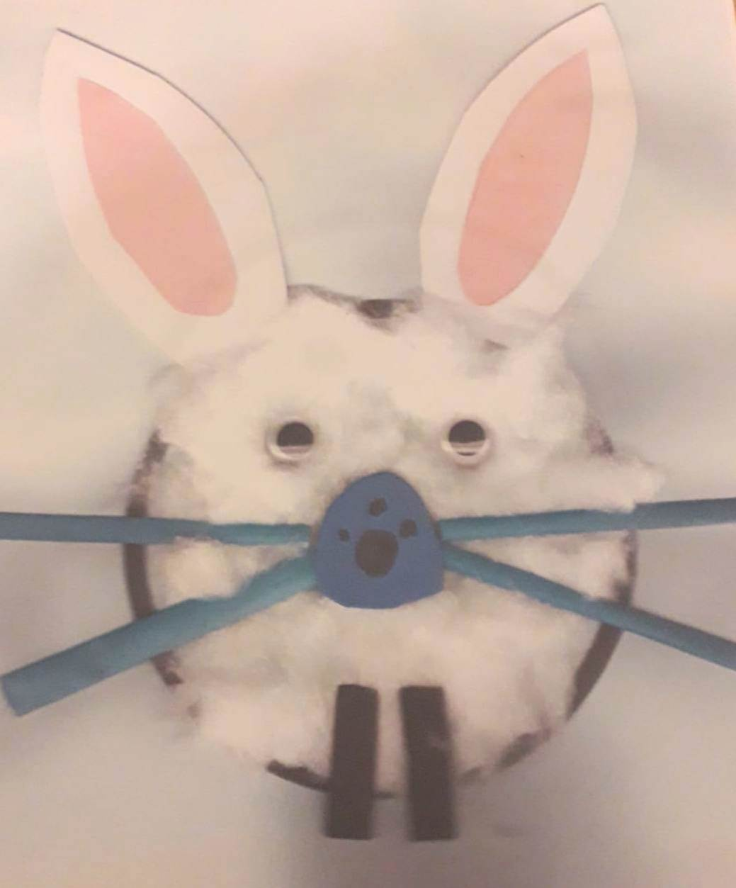
An Easter bunny face
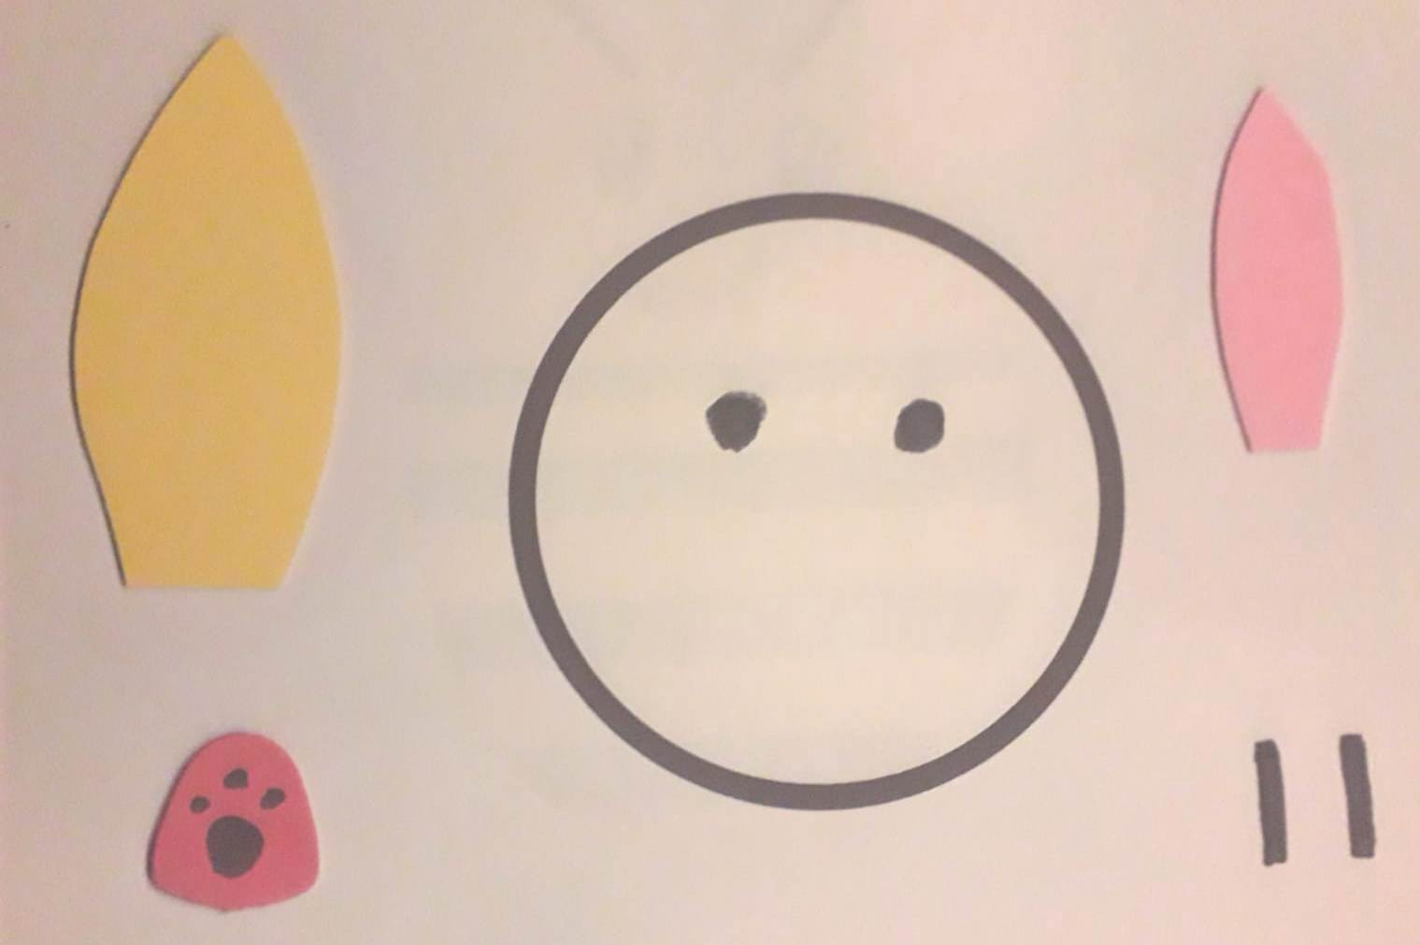
The shapes you need

