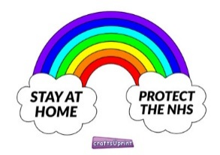
Craft ideas for Easter using things you may at home.
Recycled card, coloured cut outs from birthday cards, magazines and cardboard boxes, coloured wrapping paper, paper, cake cases, Lolly sticks or spoons
To
HAPPY EASTER
LOVE FROM
An Easter Egg
Colour, cut out and make an Easter card

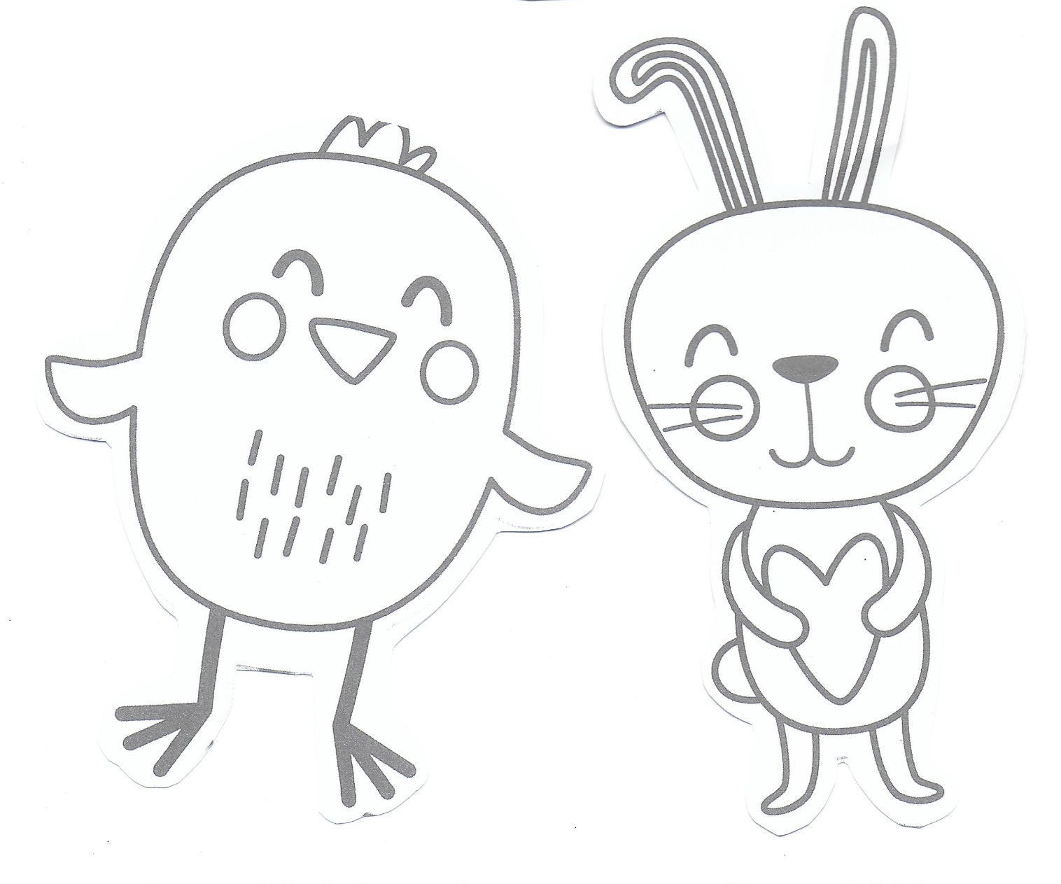
To
HAPPY EASTER
LOVE FROM
Easter bunny and chicken
Colour, cut out and put on a lolly stick, a straw or a spoon to make a puppet

