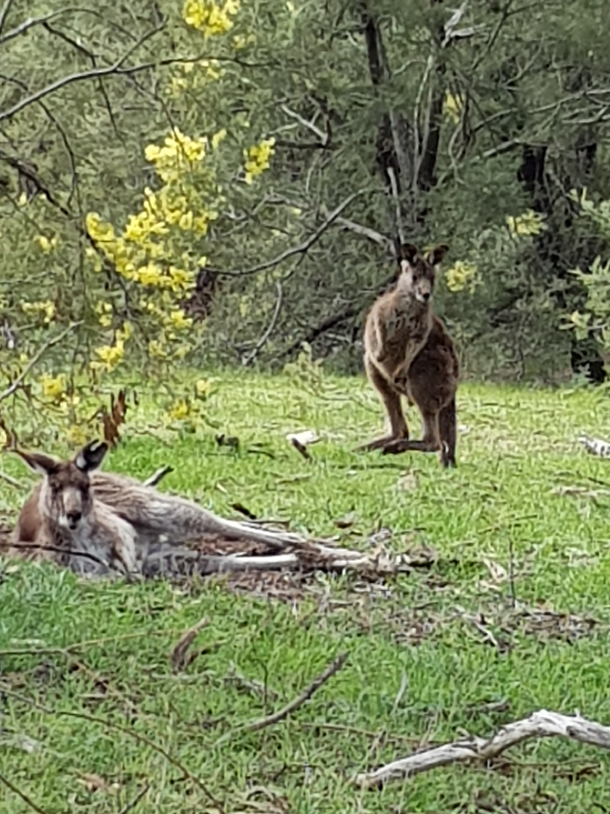  A space to breathe  A time of prayer and reflection for the people of Australia, for their safety and recovery, for thanksgiving for the beauty of every land on God’s earth, its flora and fauna, and for wisdom to prevail as together we tackle climate change and global warming. | Sunday,  26th January  2.00-5.00pm  Parish Church of St. Mary the Virgin, Davyhulme,  Davyhulme Road,  Manchester,  M41 7BU  Further details  Canon Chris Ford  0161 7482210  stmarysdavyhulme.org

