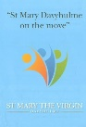‘A Church for a different World’
Introduction
During the past few months we have begun to think about the term "A Church for a different world" and what this means to us.
We began by producing a leaflet "St Mary Davyhulme on the move" which most of you will have already seen. in which we asked the congregation and the wider community to complete.
This involved asking you to express an interest in moving forward in order to:
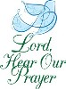
* Enhance the sacred space in this church and grounds for worship reflection and community, activity.
* Make better use of our buildings as a community facility.
* Provide a local point for art and culture.
* Improve the buildings and grounds in order to achieve this.
It is very important to realise and understand that changes are needed for worship, and that we are not envisaging re ordering our worship setting primarily so that we can have events. We are re ordering for worship so that this core activity is fit for the age we live in. From this will come an incredible enhancement of our potential as a community hub and will enable us to be more flexible for events. We need to address our interior life and our external mission both at the same time and need to link all of this to our mission statement which is to be a sacred place of quiet and prayer and be able to serve the local community.
All this information was collated and everyone that participated was invited to a next steps meeting. At this meeting we divided into several groups to explore and develop ideas with you all.
Two of the groups were FLEXIBILTY and ACCESS.
1. Wedding
2. Member of the congregation who becomes a wheelchair User
3. Visually impaired Person.
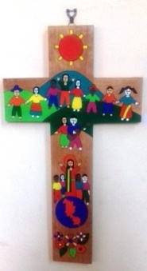
4. Baptism

What we need to be able to do and think about.
We need to prioritise our needs and have compiled a list from the information provided by to share with you. We feel that in order to improve access we need to have a more flexible arrangement within our church which includes the following:
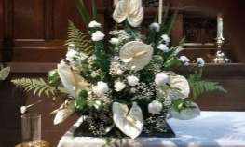
1. The Church to be all inclusive for everyone.
2. The Church to be more suitable for a broadening our present scope of worship - our eucharists and such services as weddings, baptisms and confirmations – as well as an extension of appropriate community activities.
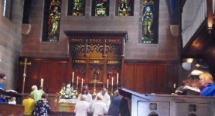
3. All members of the congregation or audience to be able to see, hear and participate in the proceedings, irrespective of where they are located within the Church. The Audio, Visual and Wi-Fi systems to be easily configured to accommodate a wide range of different activities.
4. Improve the ability to use the whole of the Church’s estate, both the indoor & outdoor spaces, with the Choir Vestry being better integrated into the rest of the building by virtue of having a floor at the same level of the rest of the building and a ramp or level floor from the front door to the porch so that everyone has a choice from which entrance to enter. The buildings where possible to meet current standards for safety, accessibility etc.
5. Seating to be durable, comfortable and easy to reconfigure to suit congregations and audiences of varying numbers and ages. To allow wheel chair users and those with prams more choice where to sit and participate. On occasions when the seating capacity of the main church building is insufficient then suitable provision should be made for overflow of the congregation or audience, possibly into the Church Hall.
6. The Church to be better able to accommodate Lent Groups, Baptism Preparations, Christmas Fairs, School Activities (including “Experiencing Christmas & Easter”) and Choirs and Music Groups, with the Chancel area being suitable for use as a stage when required.
7. More storage space to be provided to allow more flexible use of the premises in the future.
What do we want to achieve?
A space which is all inclusive to everyone's needs, especially for worship and that can accommodate the many different types of services and activities that we currently have. That our Church can be more accessible and be used by the wider community for events, parties, meetings, fairs, conferences, concerts etc....

How can we achieve this?
We invite and welcome your participation. This is a journey, a journey we travel together as the people of God, guided by God. If one or more of these areas is of particular interest to you, please fill out one of the forms. There will also be sticky note pads available at the back of Church to share any other thoughts you may have on making this church fit for mission. Have you seen some church project or scheme, a work of art in a church, which inspires you? Share it with us. These will be added to our Consultation information board on which we will begin to map out our plans. Please include these matters in your prayers, as many of you do already.
Regarding finance. As many congregations have found in the past, if this is the right thing to do we will be provided with the resources to accomplish our vision. We will be looking at ways of attracting grants in addition to the income which is created at a local level and within the congregation. The more exciting our vision, the more we will create interest beyond the immediate congregation. We have an opportunity to create a set of buildings which will not only see us out, but will serve future generations in the great Christian centuries to come.
Please do begin to think and pray about the exciting times ahead, and to enable our vision to begin to grow.

